TABLE MANIPULATION FUNCTIONS
NOTE: These functions return a table or manipulating existing table.
This function can apply “New Table”.
INPUT DATA :1) Tablemanipulate -table
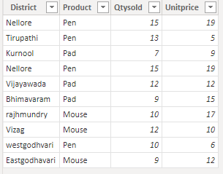
2) cost –table 3) sale -table
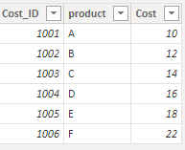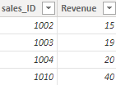
4) Sales_tabmanipulate1 –table 5) Sales_tabmanipulate2 -table
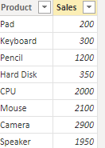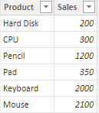

1) ADDCOLUMNS: By using this function, we can return a table with added calculated columns to the given table by append mode.
Syntax: ADDCOLUMNS(<table>, <name>, <expression>[, <name>, <expression>]…)
NOTE: In this, keep all existing columns in the table and add more columns to that, that means starting with existing columns.
In this, we can use multiple columns also.
In this we can use “New Table”
Dax Function: Addcolumns = ADDCOLUMNS(Tablemanipulate,
"Total sales",CALCULATE(SUM(Tablemanipulate[Qtysold]) * SUM(Tablemanipulate[Unitprice]))
)
Output: 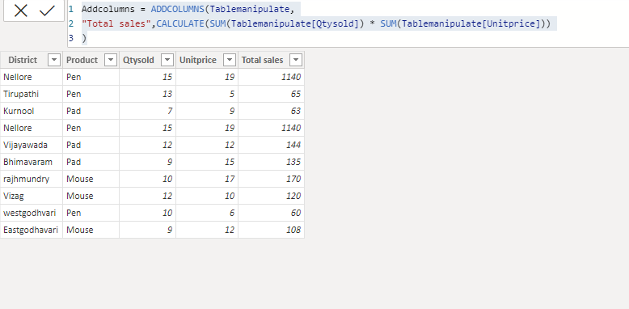

2) SELECTCOLUMNS: By using this function, we can return a table with selected columns from the table.
Syntax: SELECTCOLUMNS(<Table>, [<Name>], <Expression>, <Name>], …)
NOTE: In this, remove all existing columns and add more columns on that,that means starting with an emapty table.
Difference between “ADDCOLUMNS” and “SELECTCOLUMNS”
In these 2 we can add multiple columns.
In this we can use “New Table”
In this “ADDCOLUMNS”, keep all existing columns that means start with existing coulumns and add more column on that.
But, in this “SELECTCOLUMNS”, remove all existing columns that means starting with an emapty table andd add more columns on that.
Dax Function: Selectcolumns = SELECTCOLUMNS(Tablemanipulate,
"District",Tablemanipulate[District],
"Product",Tablemanipulate[Qtysold],
"Qtysold",Tablemanipulate[Qtysold],
"Unitprice",Tablemanipulate[Unitprice],
"Total sales",CALCULATE(SUM(Tablemanipulate[Qtysold]) * SUM(Tablemanipulate[Unitprice]))
)

Output:
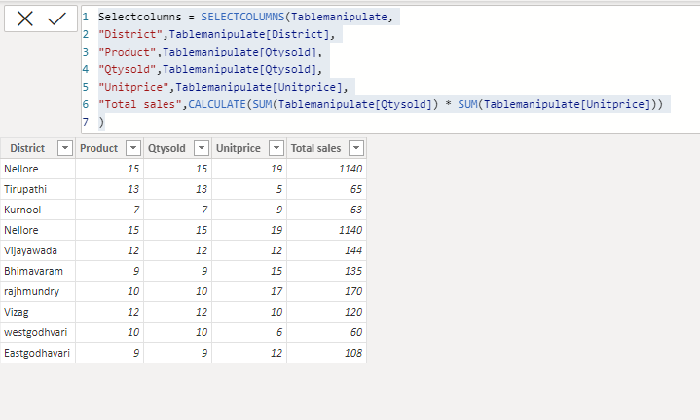
3) DISTINCT column: By using this function, we can remove the duplicates values and to the return the only unique values.
NOTE: in this we can use single column.
In this we can use “New Table”.
Syntax: DISTINCT(<column>)
Dax Function: Distinct column = DISTINCT(Tablemanipulate[Product])
Output:
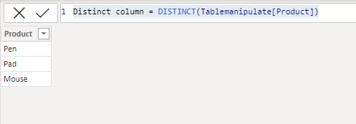
4) VALUES: By using this function, we can remove the duplicates values and to the return the only unique values.
NOTE: in this we can use single column.
It just like as DISTINCT column.
In this we can use “New Table”.
Syntax: VALUES(<TableNameOrColumnName>)
Dax Function: Values = VALUES(Tablemanipulate[Product])
Output:
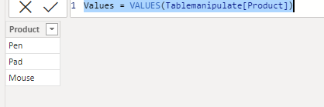

5) DISTINCT table: By using this function, we can remove the duplicates rows and to the return the only unique rows values.
NOTE: in this we can use single table.
In this we can use “New Table”.
Difference between “DISTINCT column” and “DISTINCT table “is,
In Distinct column, remove the duplicate values in that column and returns unique column values but in distinct table remove the duplicate rows in that table and returns unique row values.
Syntax: DISTINCT (<table>)
Dax Function: Distinct table = DISTINCT(Tablemanipulate)

Input: Output:
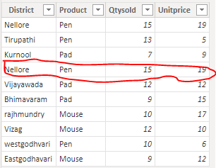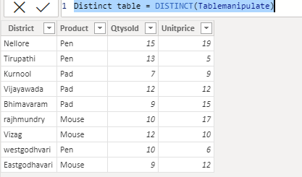
6) DATATABLE: By using this function, we can create the table.
Syntax: DATATABLE (ColumnName1, DataType1, ColumnName2, DataType2..., {{Value1, Value2...}, {ValueN, ValueN+1...}...})
NOTE: In this we can use “New Table”.
In power bi, creating a table in 3 ways.
1) Typing & pasting
2) DAX function table
3) Table constructor

Dax Function: datatable = DATATABLE(
"District",STRING,
"Product",STRING,
"Qtysold",BOOLEAN,
"Unitprice",BOOLEAN,
{
{"Hyderbad","pen",100,100},
{"Hyderbad1","pen",100,100},
{"Hyderbad2","pen",100,100}
}
)

Output:
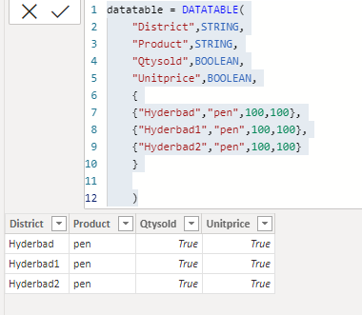
7) GENERATESERIES: By using this function, we can generate the values as sequentially.
Syntax: GENERATESERIES (<startValue>, <endValue>[, <incrementValue>])
NOTE: In this start value is less than end value.
By default incrementvalue is “1”.
Dax Function: Generateseries = GENERATESERIES(1,20,4)Output:
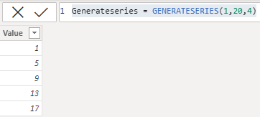
8) CROSSJOIN: By using this function, return a table that is cross join of the specified tables.
Syntax: CROSSJOIN(<table>, <table>[, <table>]…)
NOTE: In this we must take minimum 2 tables.
All column names are must be different in all tables.
The total number of rows returned by crossjoin, is eqal to the product of no.of rows in all tables.
Example: If Table A has 6 rows and table B has 4 rows then
The total number of rows=46* 4 =24
The total number of columns returened by crossjoin,is equal to the sum of the total number of columns in all table.
Example: Table a has 3 columns, table B has 2 then
The total number of columns=3+2=5

Dax Function: Cross join = CROSSJOIN(cost,sale)
Output: 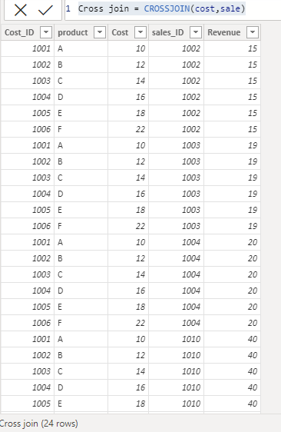
9)EXCEPT : By using function, we can display only the rows from left hand side table which are not matched from Right side table.
Syntax: EXCEPT(<table_expression1>, <table_expression2>
NOTE: In this use 2 tables only.
It just like as “LeftAnti” join.
Dax Function: Except = EXCEPT(Sales_tabmanipulate1,Sales_tabmanipulate2)
Output:
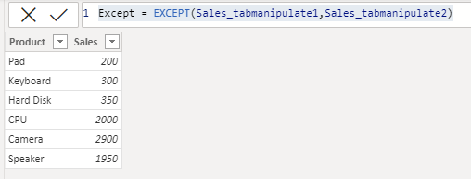
10) UNION: By using this function, we can combine rows from multiple dataset.
Syntax: UNION(<table_expression1>, <table_expression2> [,<table_expression>]…)
NOTE: In this we can use more than 2 tables.
It just like as full outer Join.
In this, having the same number of columns.
Duplicate values are retained (displayed)
Data types are same.
By using this function, we can combine the rows and insert record also.
Dax Function: Union = UNION(Sales_tabmanipulate1,Sales_tabmanipulate2)
Output: 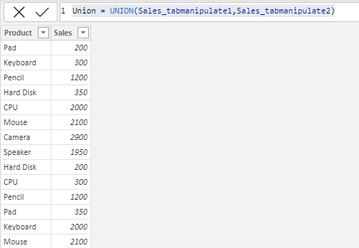
11) INTERSECT: By using this function, we can display only the matched rows from the both of the tables.
Syntax: INTERSECT(<table_expression1>, <table_expression2>)
NOTE: In this we can use only 2 tables.
It just like as “Inner Join”.
Dax Function: Intersect = INTERSECT(Sales_tabmanipulate1,Sales_tabmanipulate2)
Output:
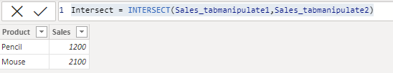
12) ROW: By using this function, we can insert rows in union function.
Syntax: ROW (<name>, <expression>[[,<name>, <expression>]…])
Dax Function: Row = UNION(Sales_tabmanipulate1,ROW("Product","Monitor","Sales",100))
Output:
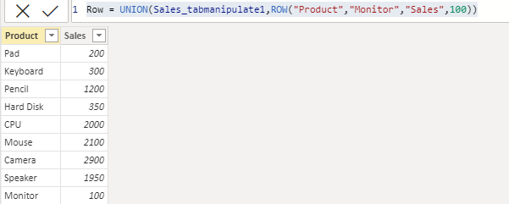
13) NATURALLEFTOUTERJOIN: By using this function, we can display the all rows from left side table, matching rows from right side table.
Syntax: NATURALLEFTOUTERJOIN(<LeftTable>, <RightTable>)
NOTE: In this function we cannot perform any filter functions.
Dax Function: Naturalleftouterjoin = NATURALLEFTOUTERJOIN(cost,sale)
Output:
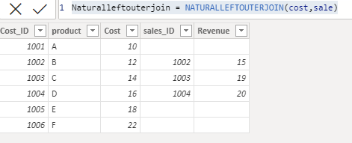
14) NATURALINNERJOIN: By using this function, we can display the only matching rows from the both of the tables.
Synatx: NATURALINNERJOIN(<LeftTable>, <RightTable>)
NOTE: It just like as “Intersect” function.
In this function we cannot perform any calculating functions.
Dax Function: Naturalinnerjoin = NATURALINNERJOIN(cost,sale)
Output:
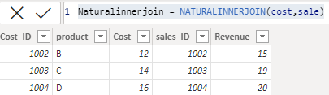
15) GENERATE: By using this function, we can return a table that is cross join of the specified tables.
Syntax: GENERATE(<table1>, <table2>)
NOTE: It just like as “Cross Join”.
After applying the calculatetable function we can get the “Inner join”. (make the relationship (1to 1)
Dax Function: 1) Generate = GENERATE(cost,sale)
2) Generate1 = GENERATE(cost,CALCULATETABLE(sale))

Output: 1) 2)
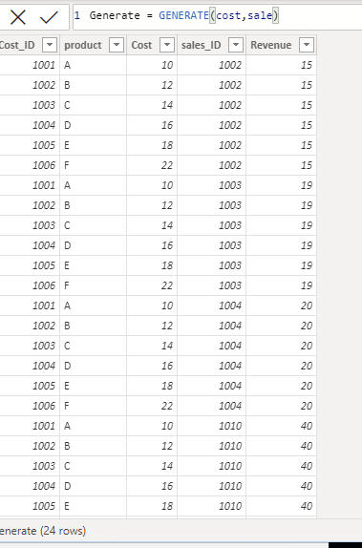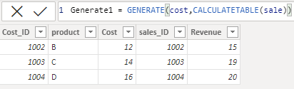

16) GENERATEALL: By using this function, we can return a table that is cross join of the specified tables.
Syntax: GENERATEALL(<table1>, <table2>)

NOTE: It just like as “Cross Join”.
Its same behavior as “Generate”
After applying the calculatetable function we can get the “Left outer join”.
Difference between “Generate” and “GenerateAll” is,
These 2 are performing like as “Cross join”.
In these 2, after applying calculated function we can get “Inner Join” and “Left outer join”

Dax Function: 1) Generateall = GENERATEALL(cost,sale)
2) Generateall1 = GENERATEALL(cost,CALCULATETABLE(sale))

Output: 1) 2)
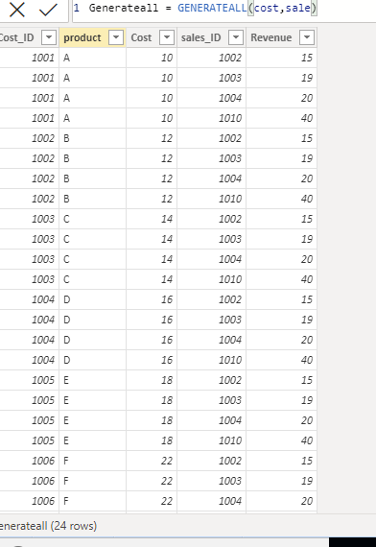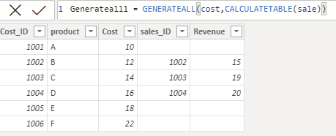

17) SUMMARIZE: By using this we can extract the data and create the table.
Syntax: SUMMARIZE (<table>, <groupBy_columnName>[, <groupBy_columnName>]…[, <name>, <expression>]…)
Dax Function: Summarize = SUMMARIZE(cost,cost[product],"total_Cost",SUM(cost[Cost]))
Output:
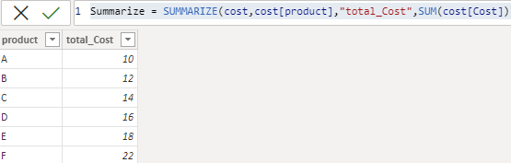
18) SUMMARIZECOLUMNS: By using this, we can extract the data and create the table.
Syntax: SUMMARIZECOLUMNS( <groupBy_columnName> [, < groupBy_columnName >]…, [<filterTable>]…[, <name>, <expression>]…)
NOTE: Difference between “SUMMARIZE” and “SUMMARIZECOLUMNS” is,
These 2 functions are perform extract the data and create the tables.
In “SUMMARIZE”, table is required but in “SUMMARIZECOLUMNS” table is not required”.
In “SUMMARIZE”, by default does not have any filter function but in “SUMMARIZECOLUMNS” having filter function.
“SUMMARIZE”, is an old function but “SUMMARIZECOLUMNS” is updated function.
Dax Function: Summarizecolumns = SUMMARIZECOLUMNS(cost[product],"total_Cost",SUM(cost[Cost]))
Output:
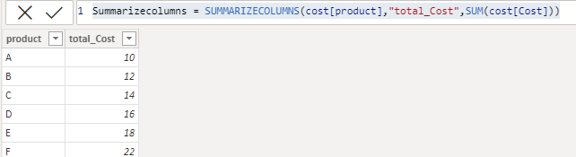

19) GROUPBY: By using this function, we can extract the data and create the table.
Syntax: GROUPBY (<table> [, <groupBy_columnName> [, <groupBy_columnName> [, …]]] [, <name>, <expression> [, <name>, <expression> [, …]]])
NOTE: These “SUMMARIZE” and “GROUPBY” perform same result, but small difference is there,
In “SUMMARIZE” we can pass only single value parameter aggregation function but in “GROUPBY” we can pass 2 parameters aggregate function.
In “SUMMARIZE” mention “Table name” but in “GROUPBY” mention “CURRENTGROUP”.
Dax Function: Groupby = GROUPBY(cost,cost[product],"total_Cost",SUMX(CURRENTGROUP(),cost[Cost]))
Output: 